

FarmEasy
Portal for farmers to sell their produce at a better rate

INT – 222
Advanced Web Development

Name – Kartavya Shrivastav
Registration Number – 12323198
Section – K23HS
Roll No. – 61
Group No. – 16
Group Members – Kartavya Shrivastav, Malay Shikhar Soni, Kumar Mayank
Submitted To – Ms. Monika Sharma

Project Overview
FarmEasy is a full-stack web application designed to address one of the most persistent challenges in the agricultural supply chain: the lack of transparency and fair pricing caused by intermediaries. The platform functions as a real-time agricultural auction system that connects farmers directly with buyers, enabling open and competitive price discovery. Farmers can list their produce with essential details such as quantity, quality, and images, while buyers participate in live auctions to place competitive bids. By eliminating middlemen, FarmEasy ensures that farmers receive fair market value for their produce while buyers benefit from transparent pricing and direct access to sellers. The application emphasizes trust, efficiency, and accessibility, making it suitable for small-scale and large-scale agricultural stakeholders alike.
The platform is built using the MERN stack, which provides scalability, flexibility, and performance for a real-time application. React is used on the frontend to deliver a responsive and interactive user interface, ensuring smooth user experience across devices. Node.js and Express.js power the backend, handling business logic, authentication, APIs, and secure communication between the client and server. MongoDB is used as the database to efficiently store user data, auction listings, bids, transaction details, and reviews in a flexible schema. Real-time bidding is enabled using WebSockets (Socket.io), allowing instant updates of bids without page refreshes. Secure online transactions are facilitated through a payment gateway integration, ensuring safe and reliable fund transfers, while email services are used to send notifications related to account verification, auction status, and payment confirmations.
The workflow of FarmEasy is structured around role-based access for farmers, buyers, and administrators. Farmers register, verify their accounts, and create auction listings for their produce. Once an auction goes live, buyers can view listings in real time and place bids that are instantly broadcast to all participants. The system continuously tracks the highest bid and declares the winner once the auction ends. Payments are then processed securely, and confirmation notifications are sent to both parties. Administrators oversee platform activity, manage users, and resolve disputes to maintain trust and system integrity. Overall, FarmEasy integrates modern web technologies with real-time communication and secure transactions to create a transparent, efficient, and farmer-centric digital marketplace.

Project Links:
GitHub Repository Link - https://github.com/Kartavya-Shrivastav/FarmEasy
Live Deployed Website Link - https://farmeasy-10ce.onrender.com

Project Snapshots:

- Landing Page (Hero Section):
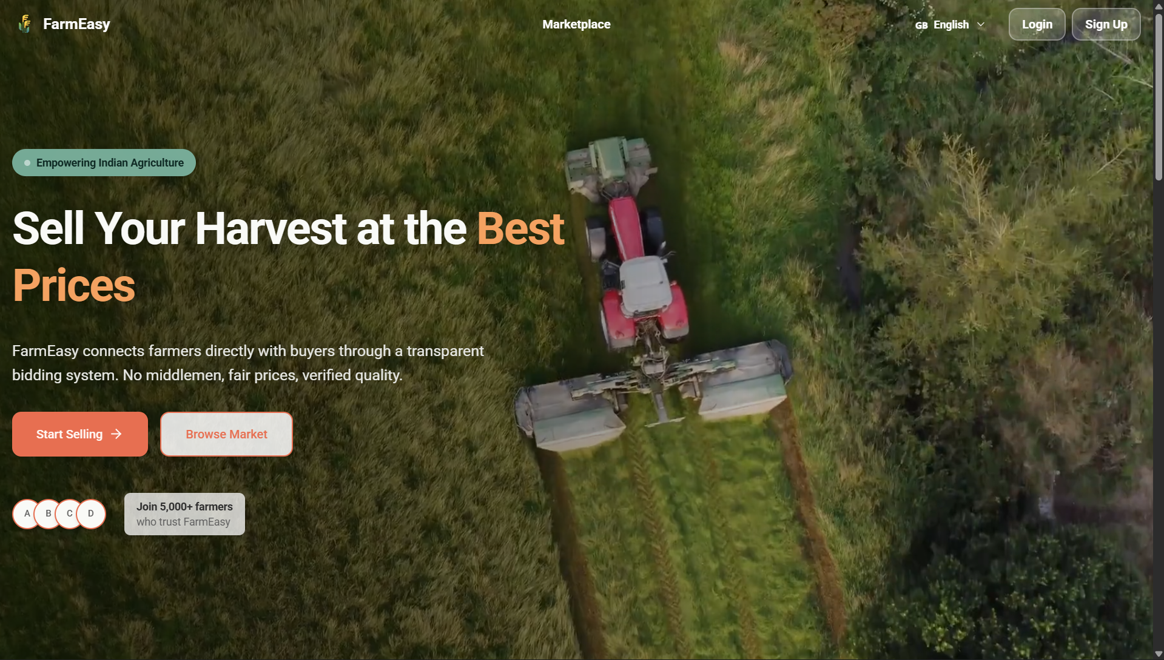

- Home Page:
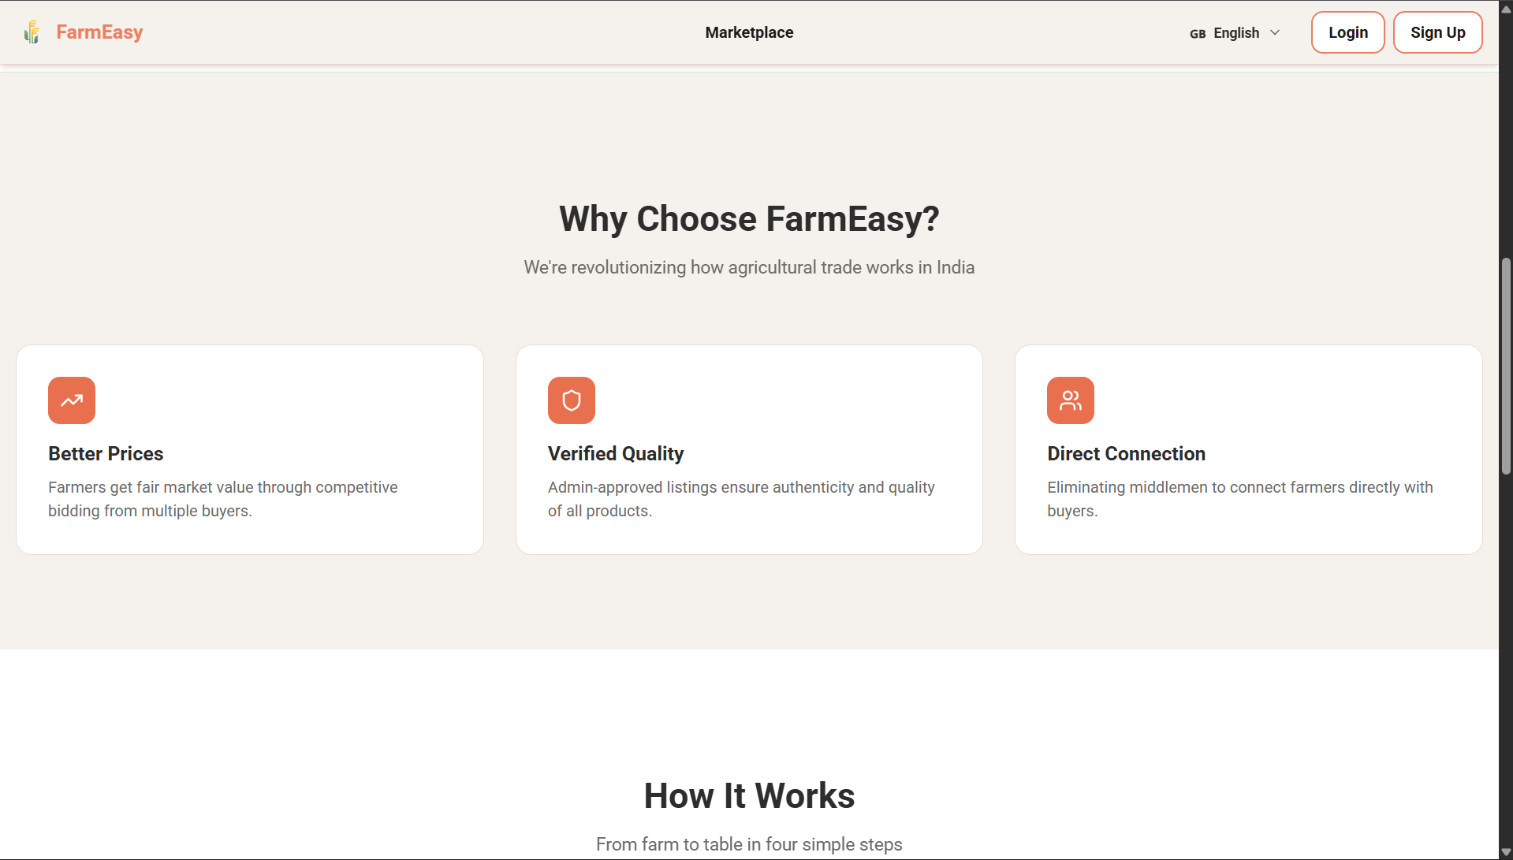
- Working Explanation:
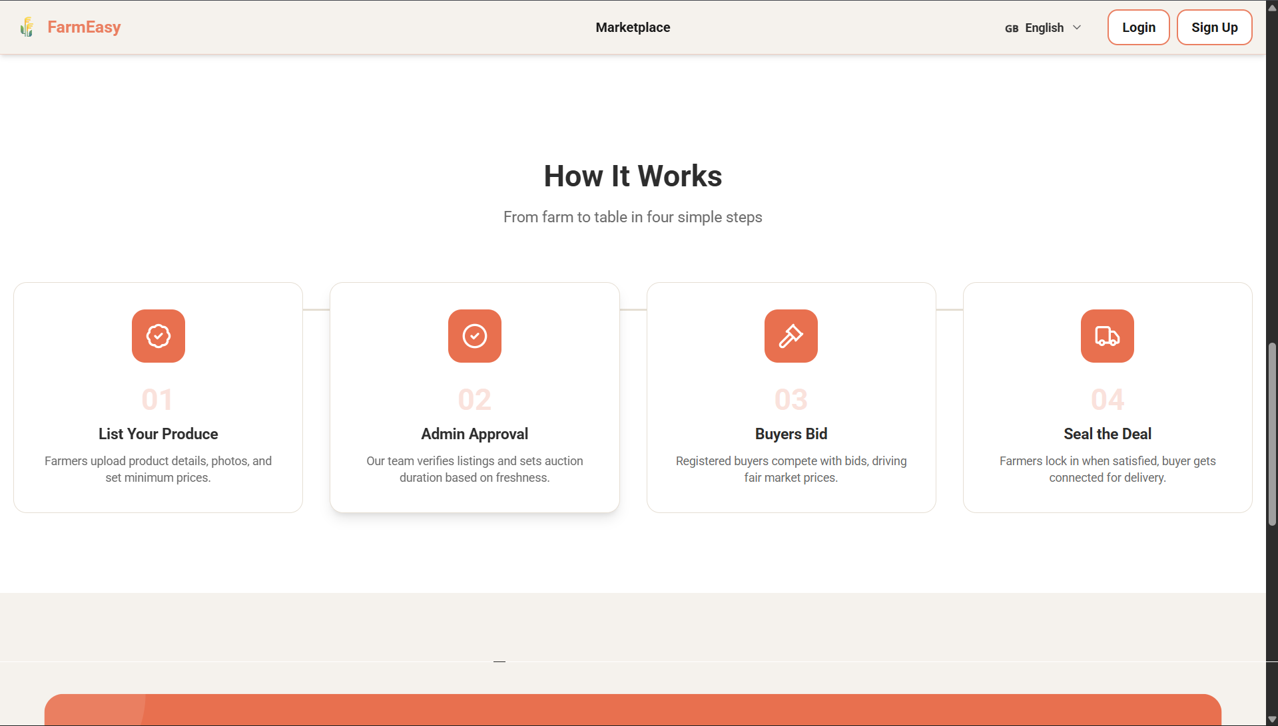

- Footer:
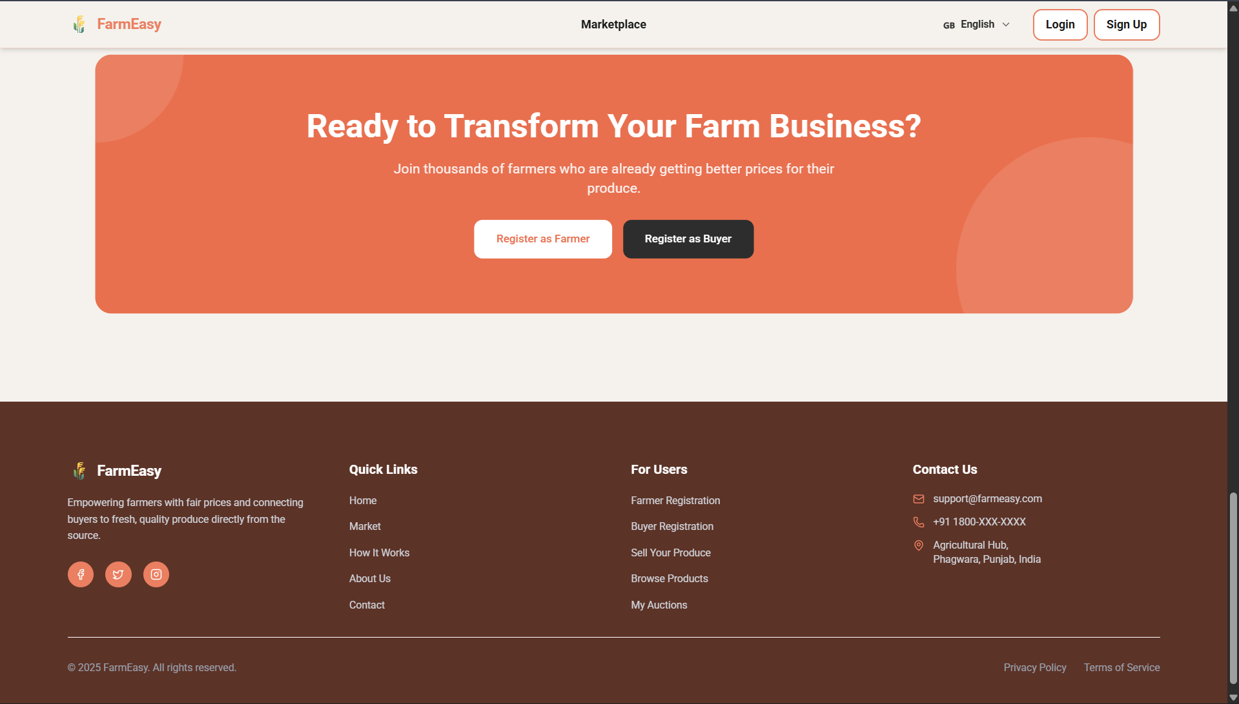

- Language Switcher:
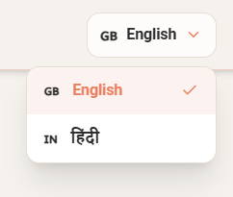

- Login Page:
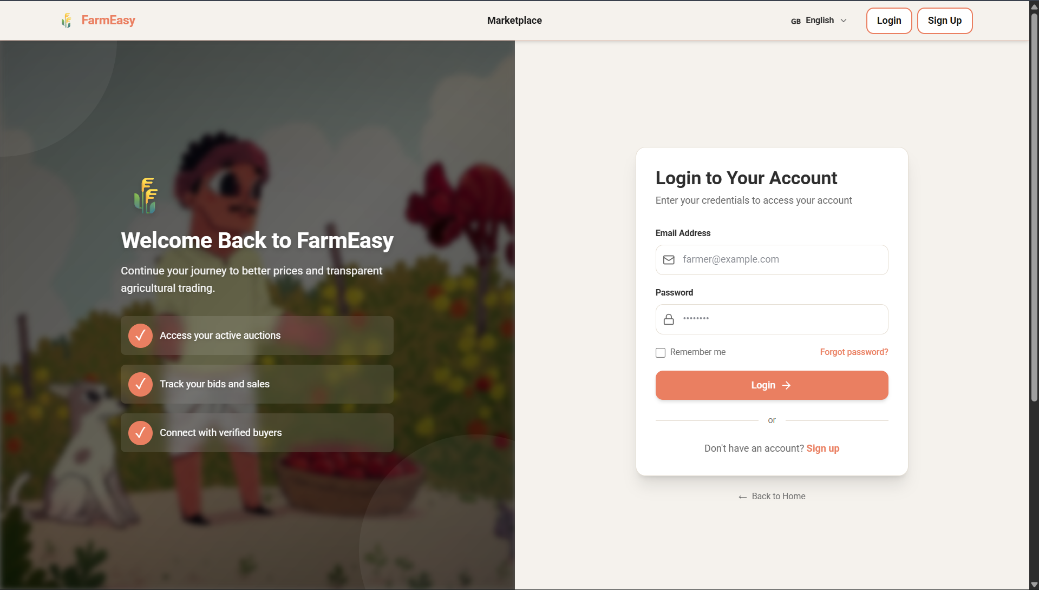

- Forgot Password:
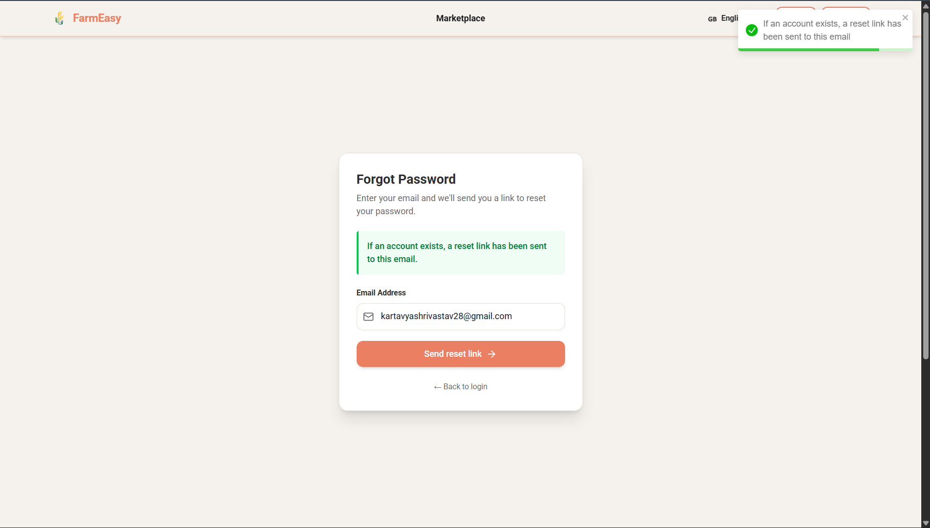

- Reset Password:
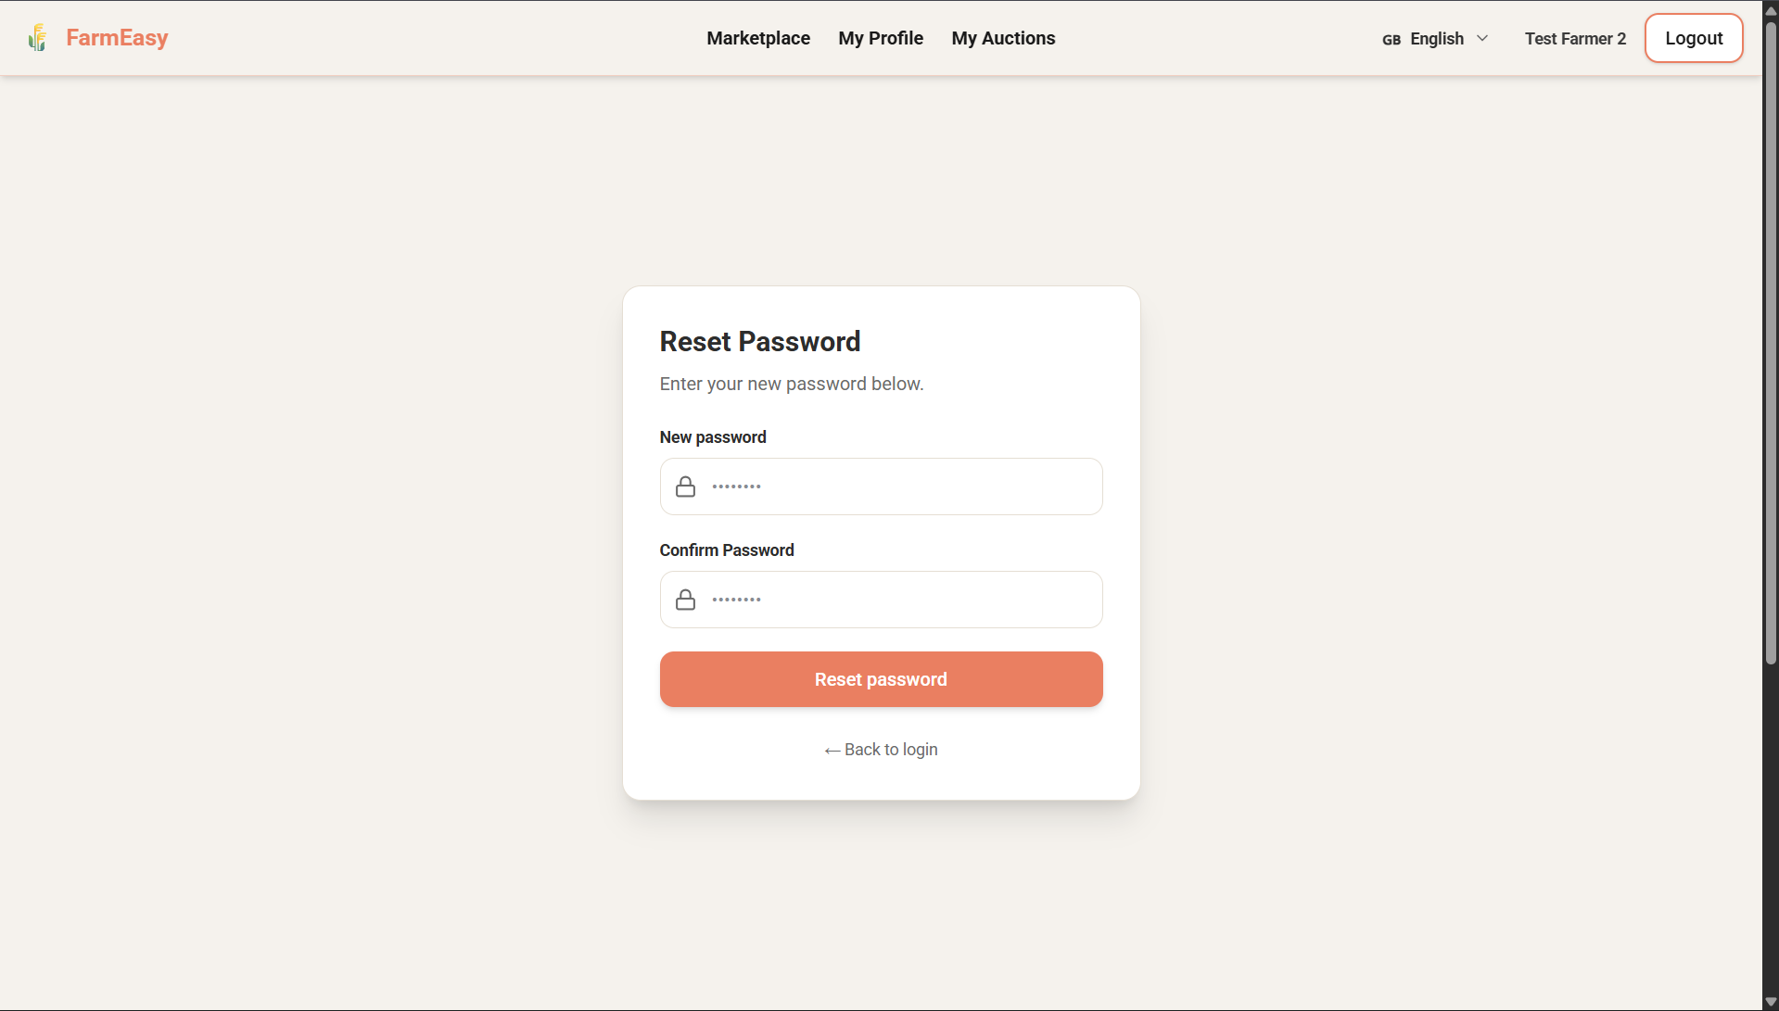

- Sign Up Page for Farmer and Buyer:
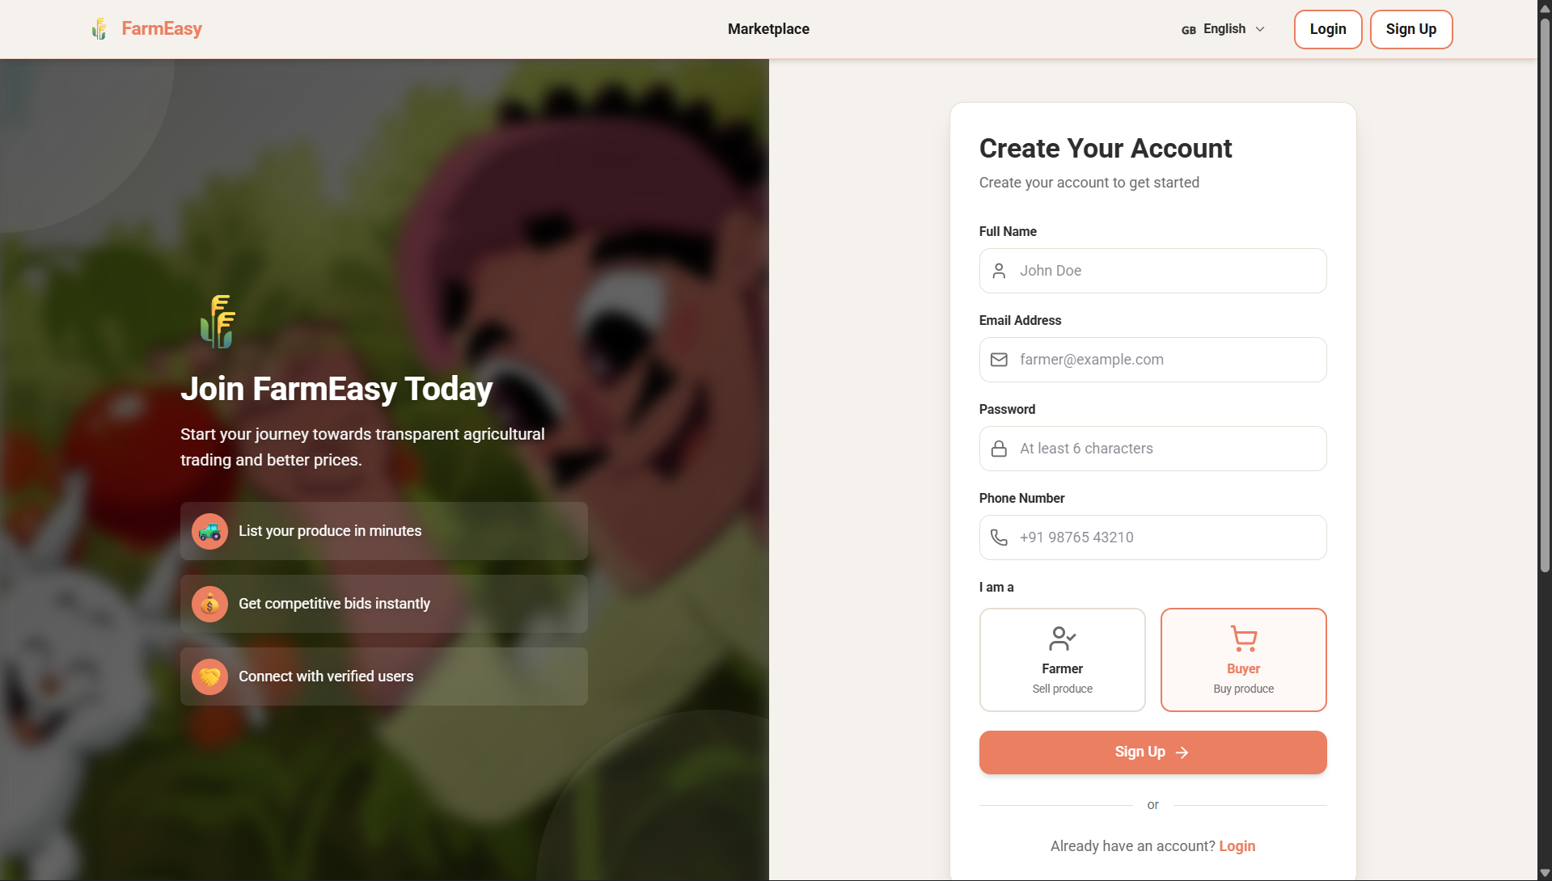

- Creating Account:
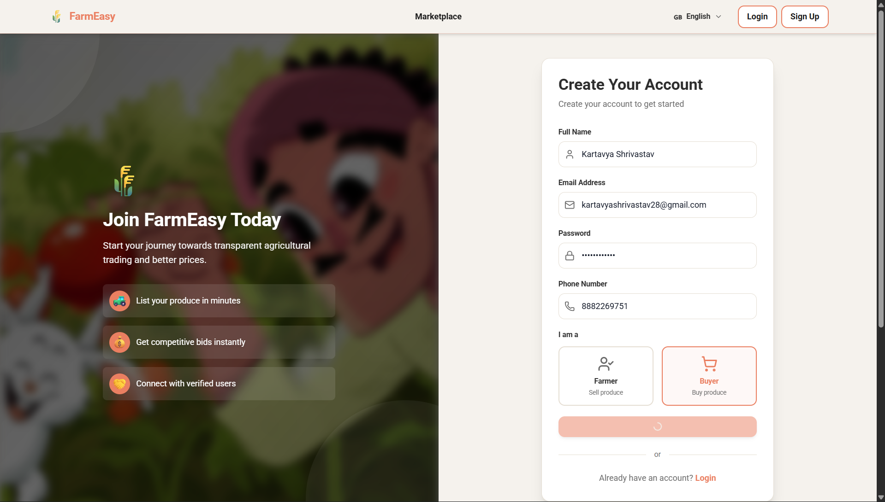

- Marketplace:
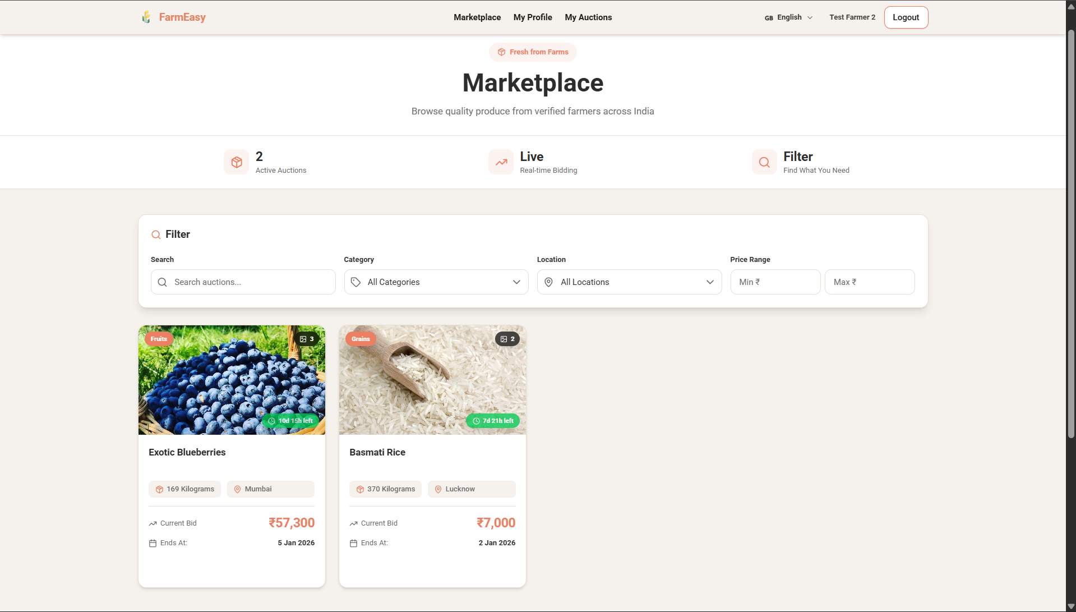

- Farmer Profile Page:
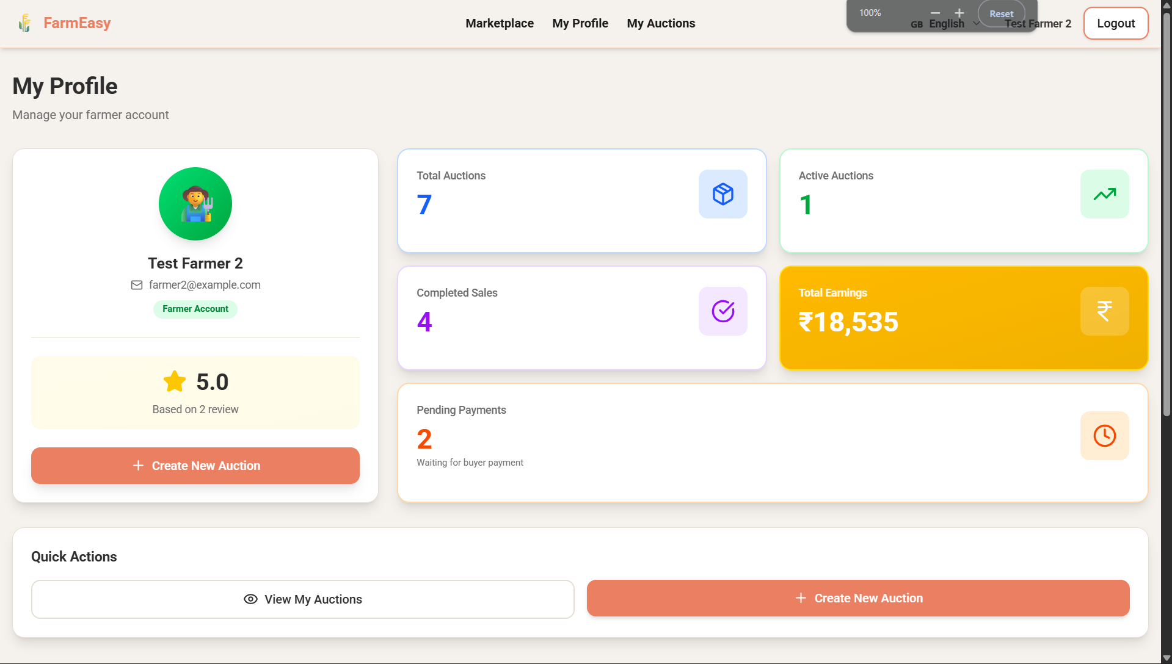

- Farmer’s My Auction Page:
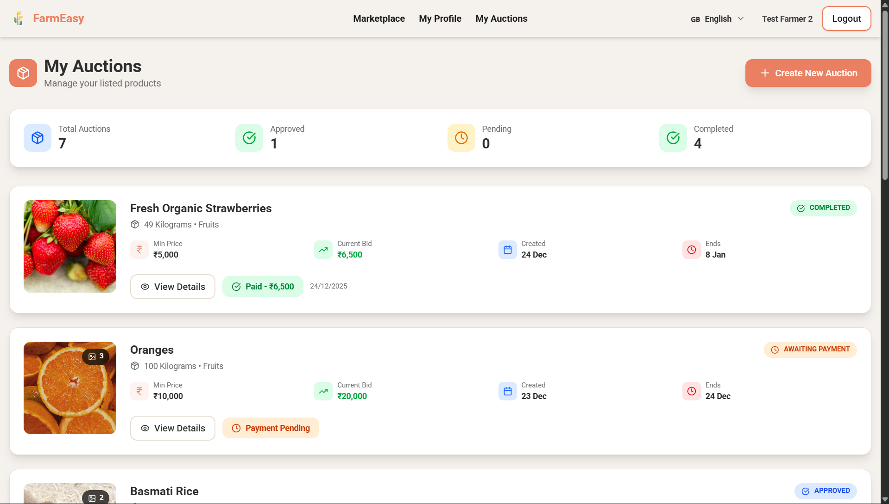

- Farmer’s Create Auction Page (Zoomed Out at 80%):
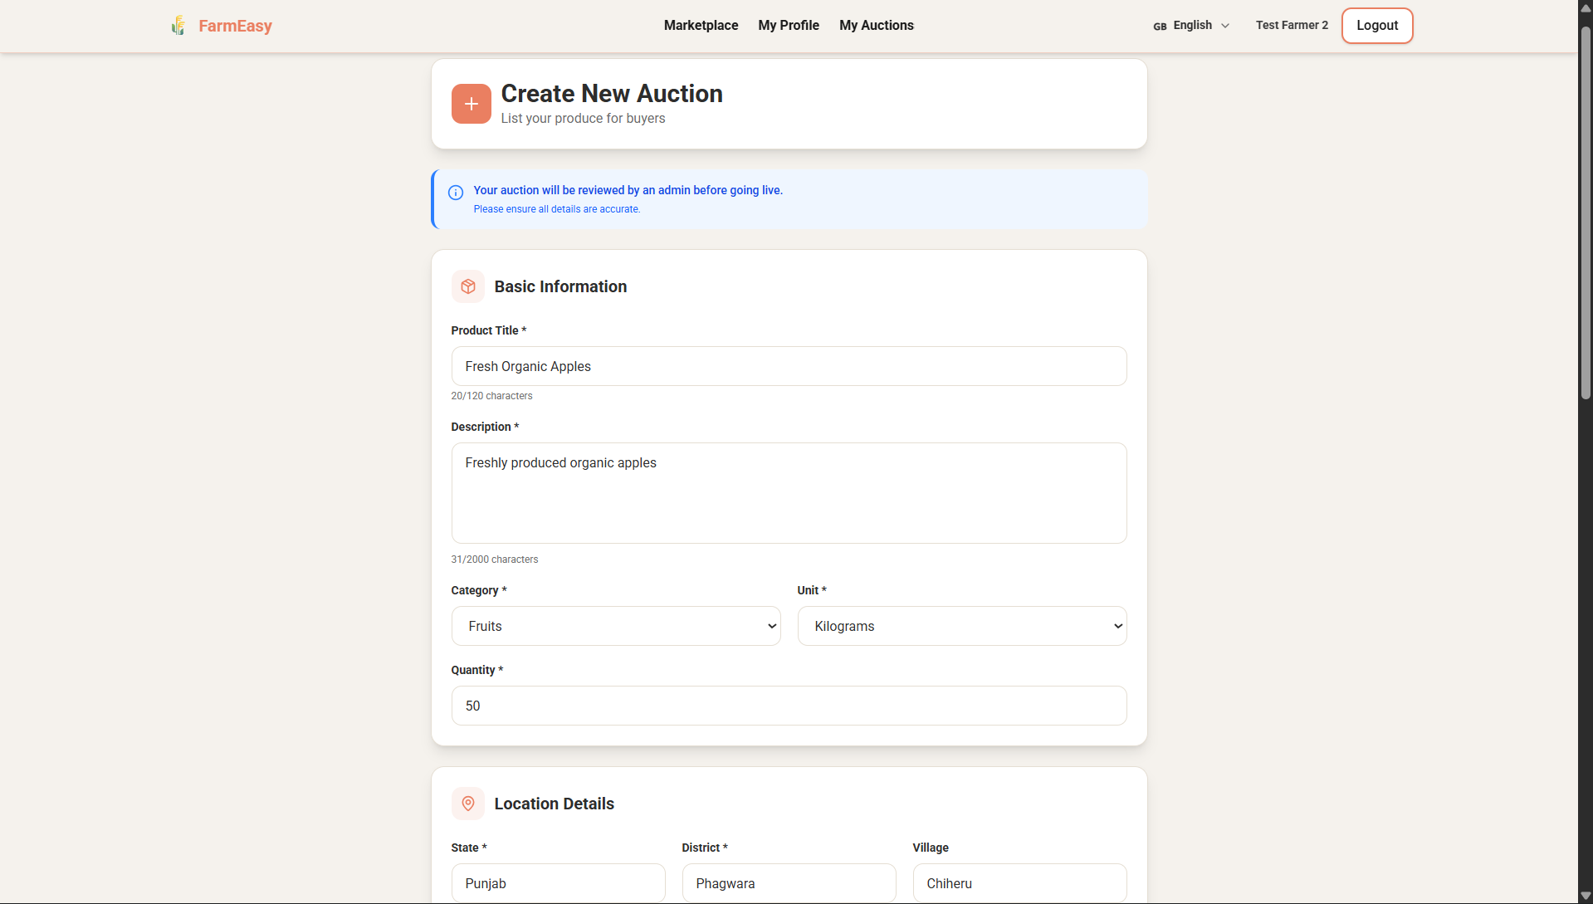
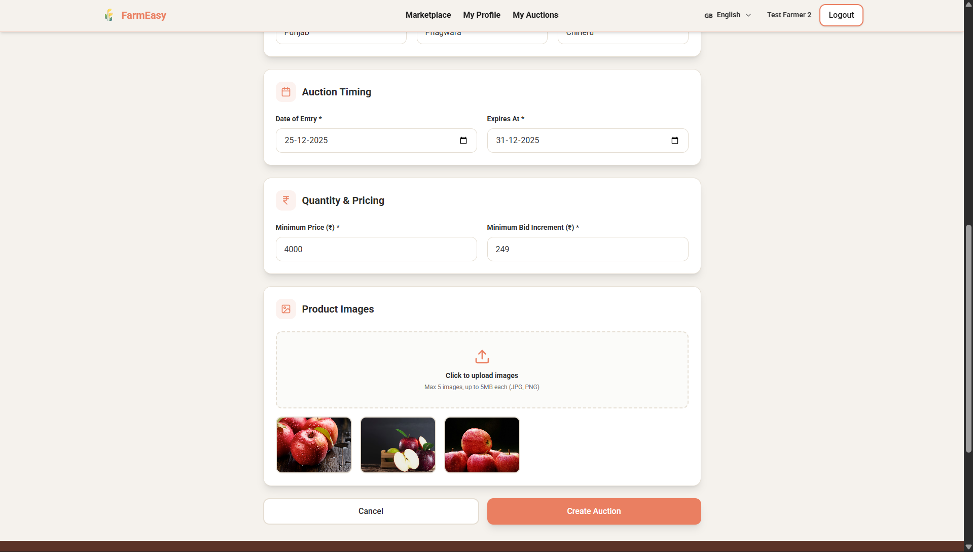

- New Auction added:
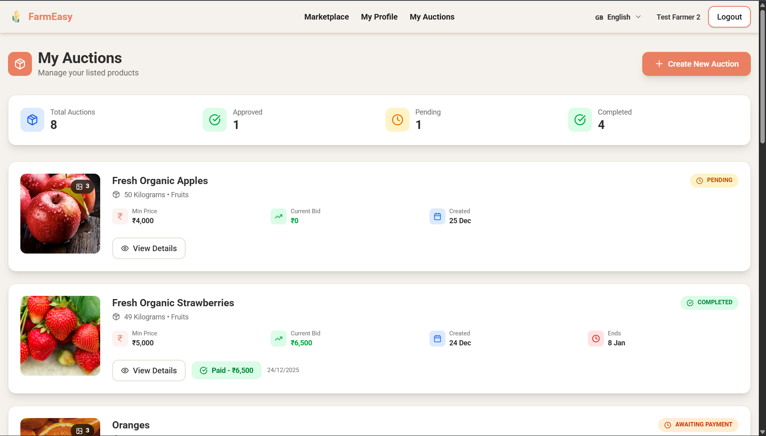

- Admin Dashboard:
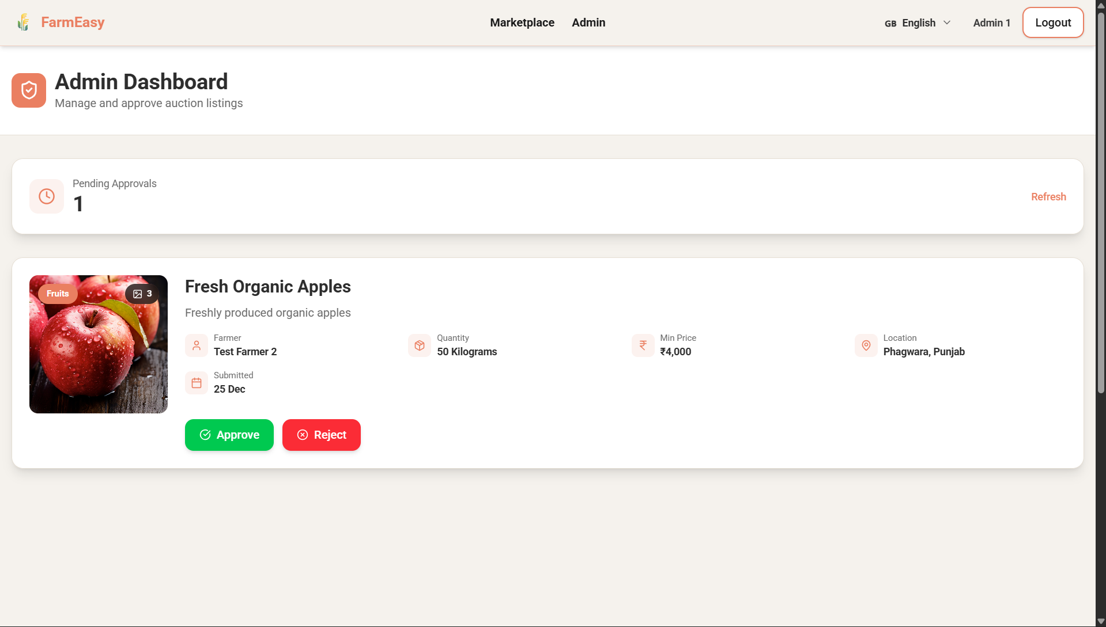
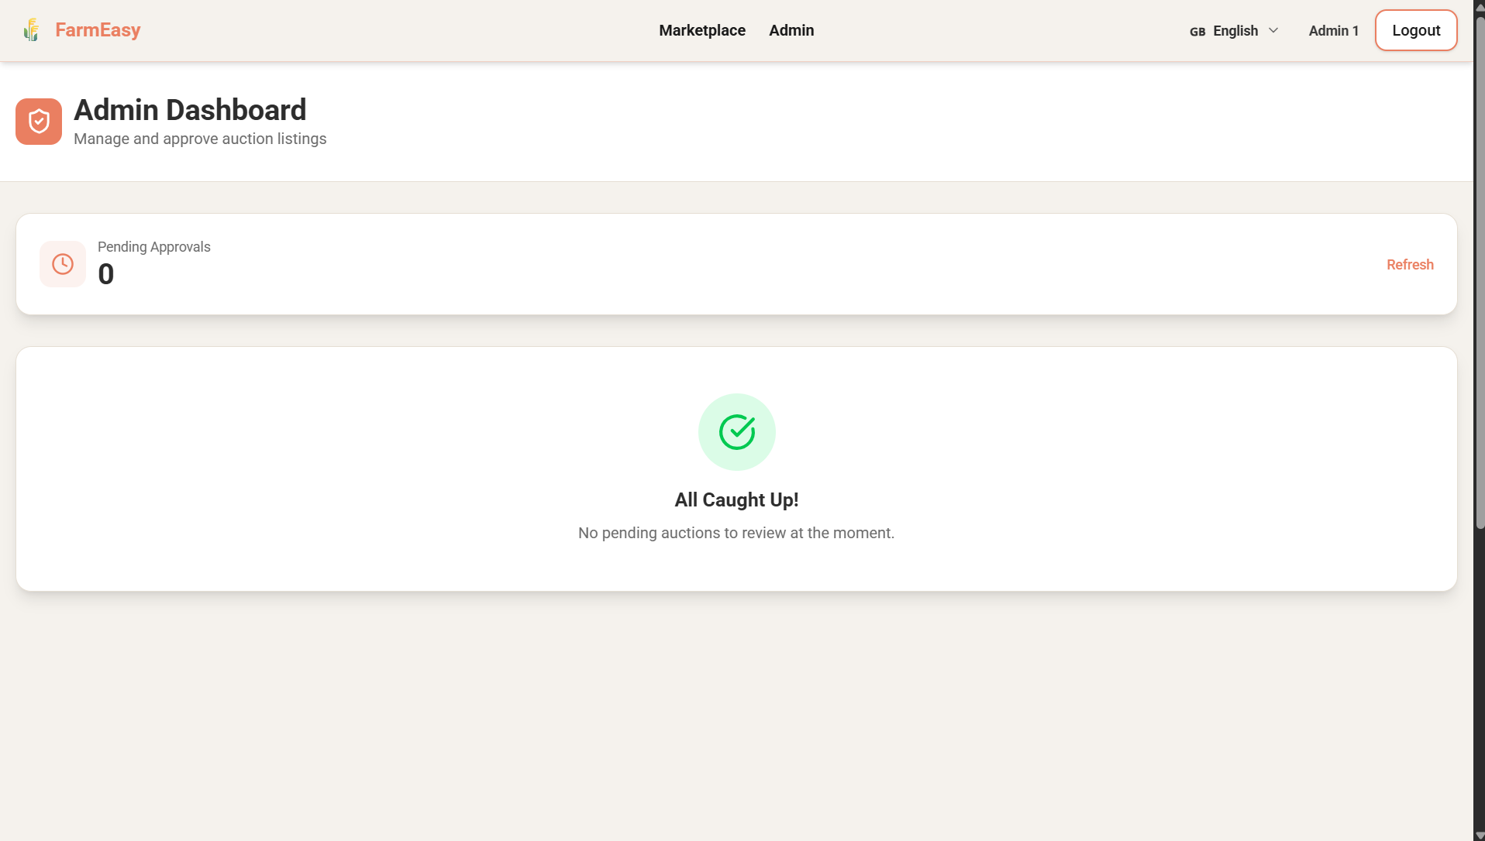

- Buyer Dashboard:
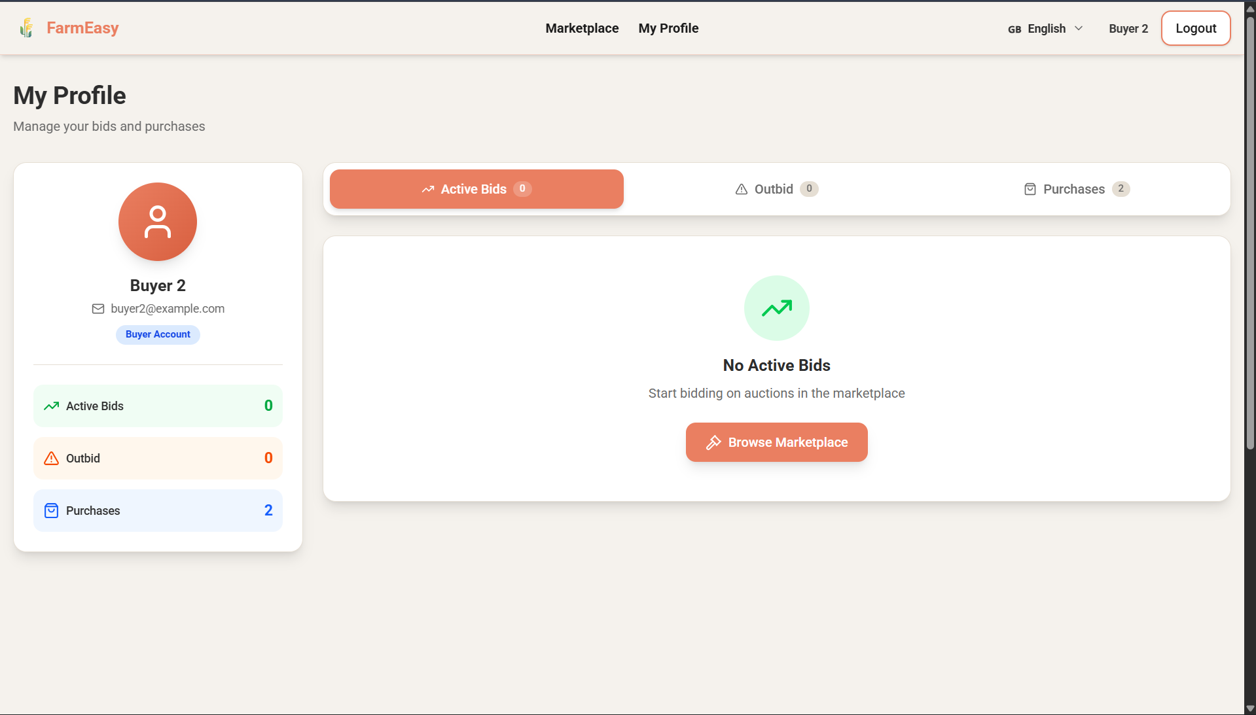

- Bidding dashboard for buyer:
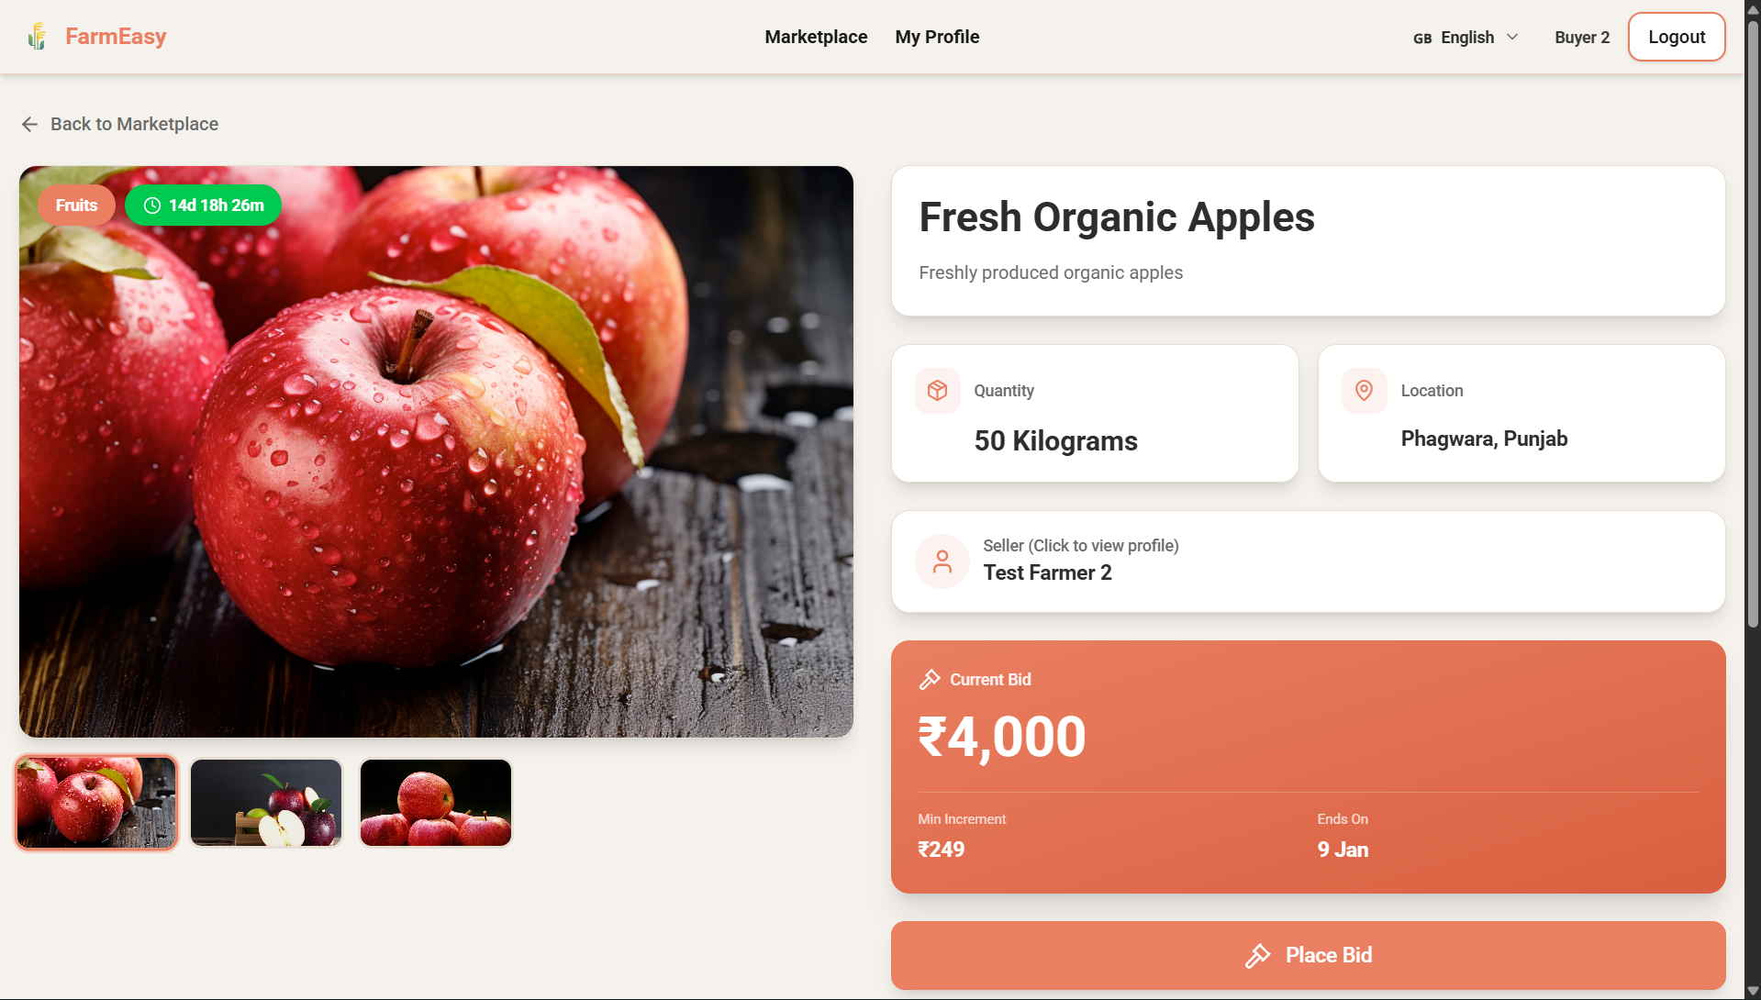

- Placing the bid:
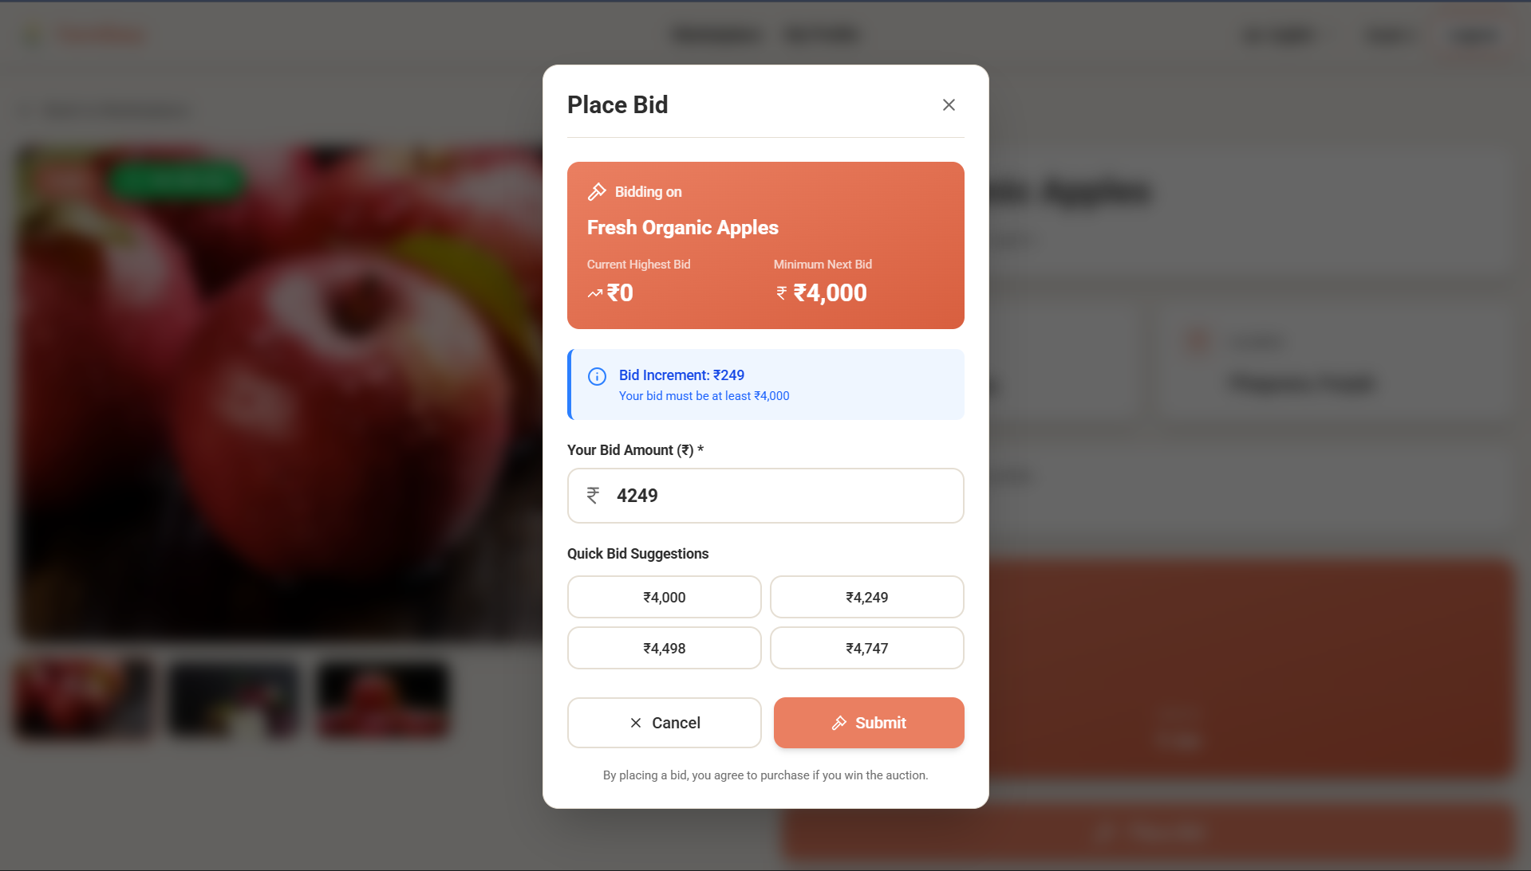

- Farmer Dashboard for Locking the deal:
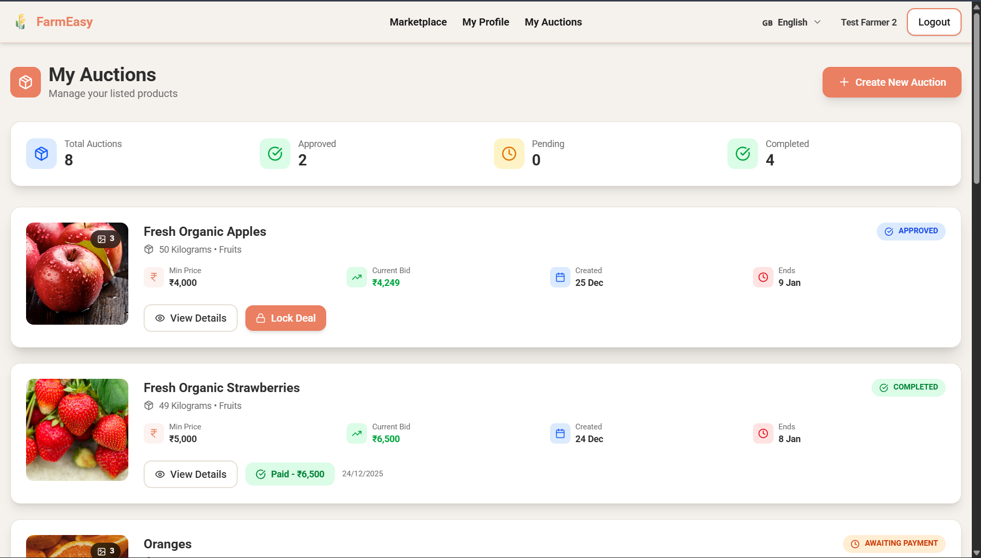

- Buyer Dashboard for payment:
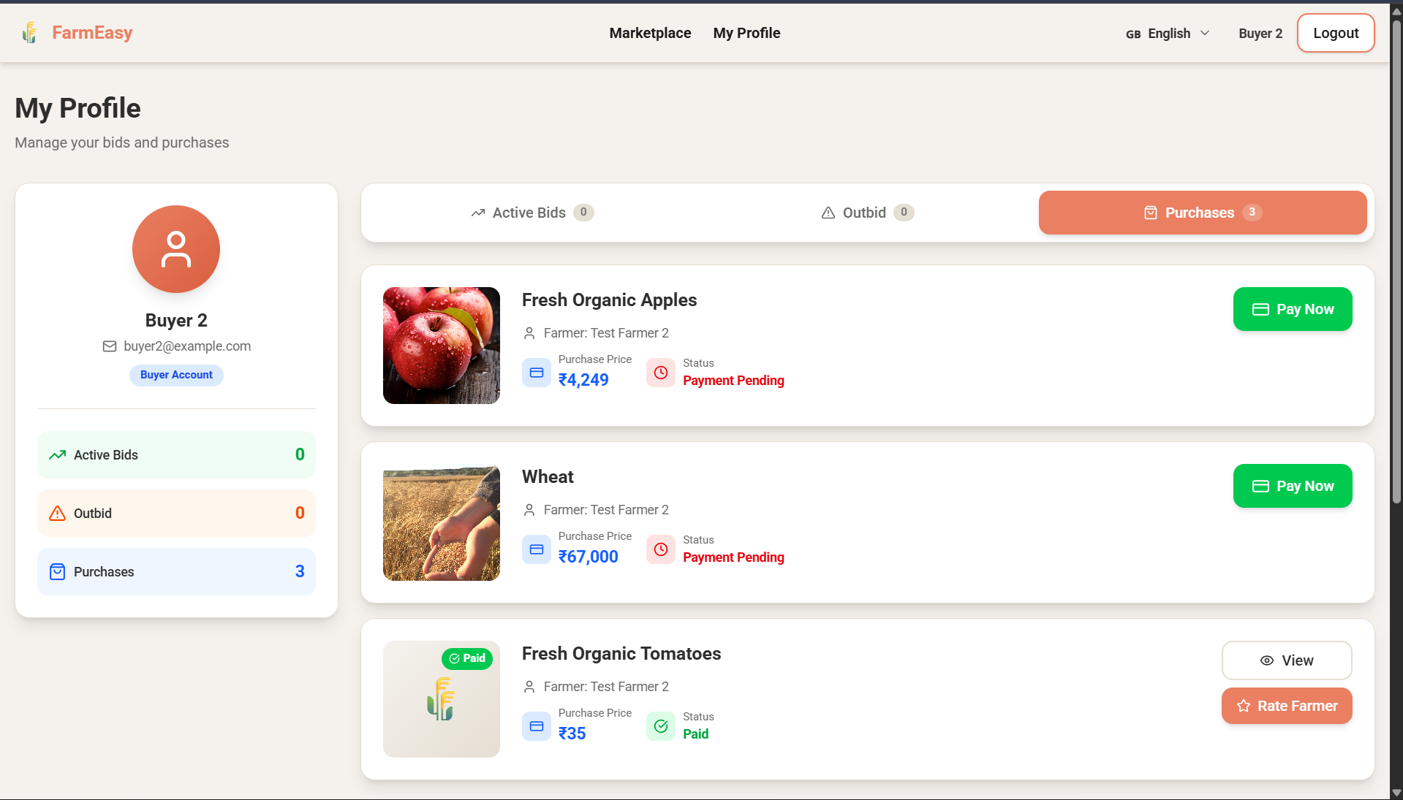

- RazorPay Payment Portal:
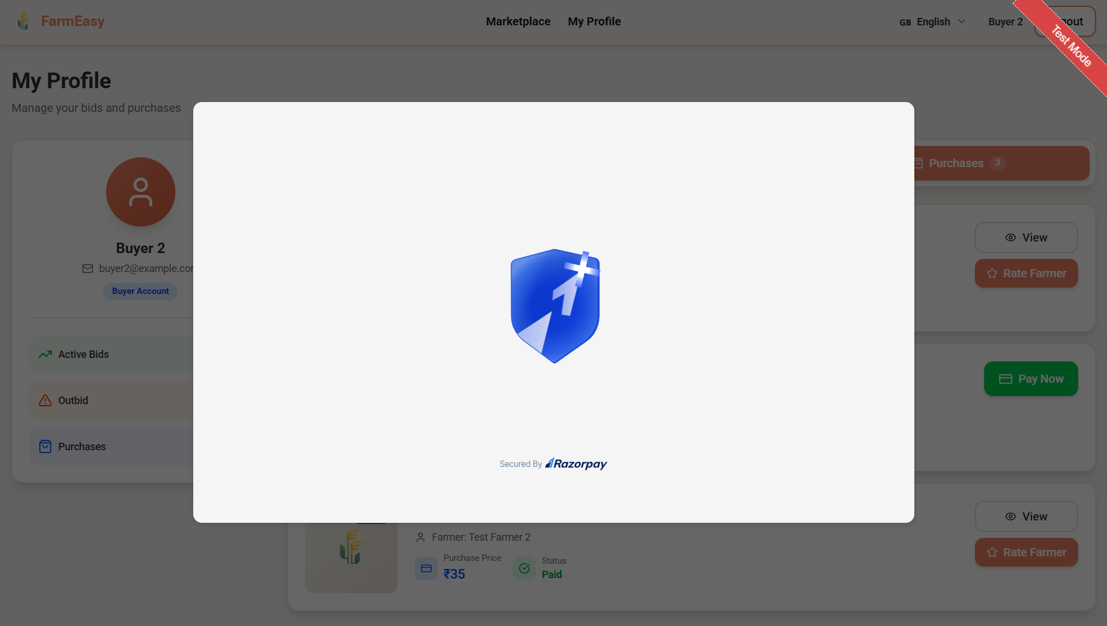
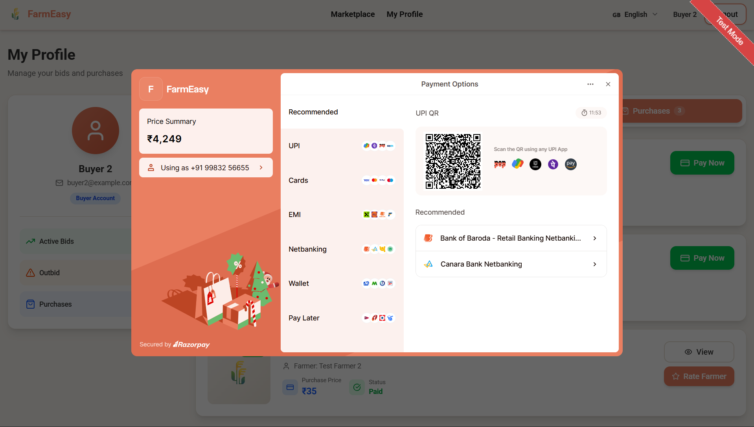

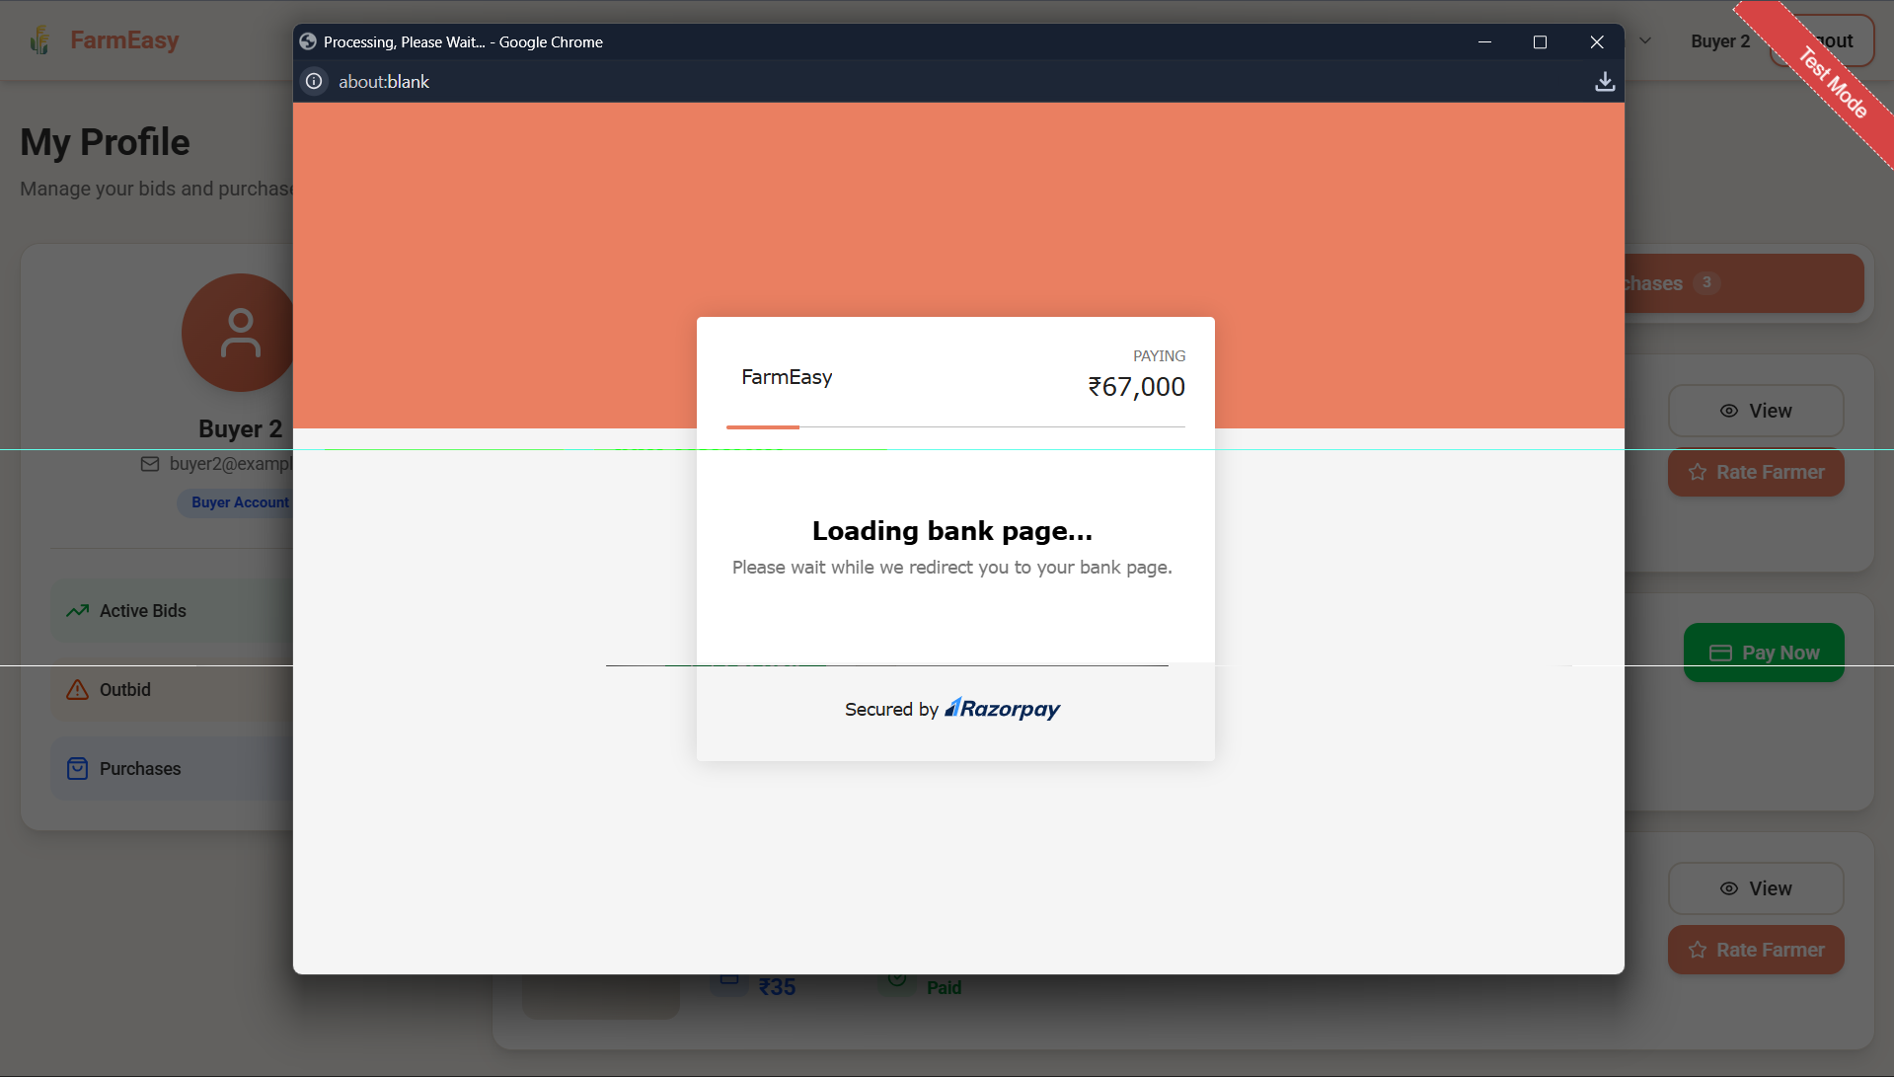

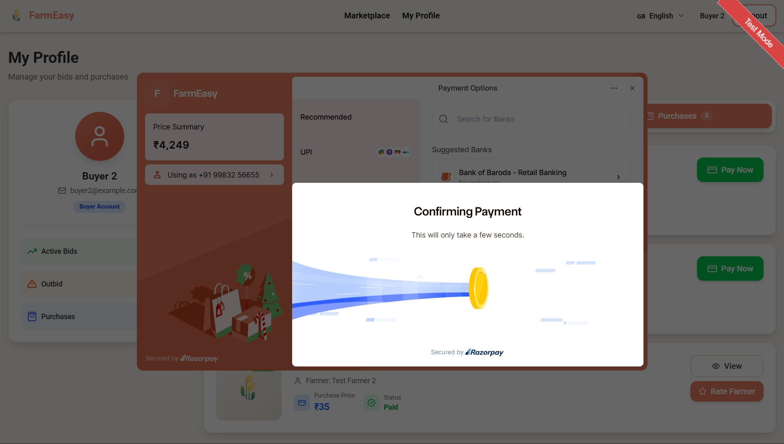
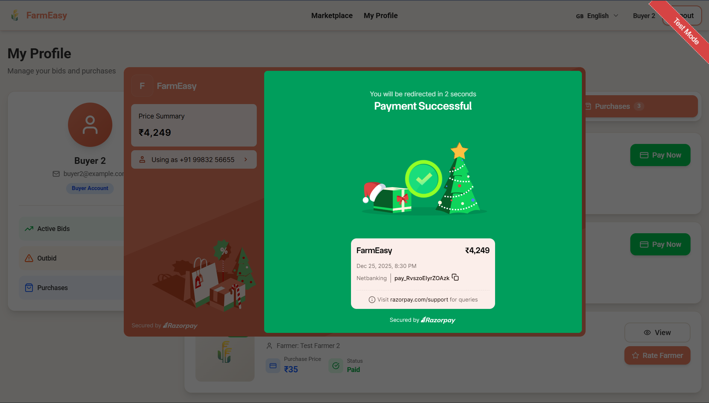

- Purchase Review:
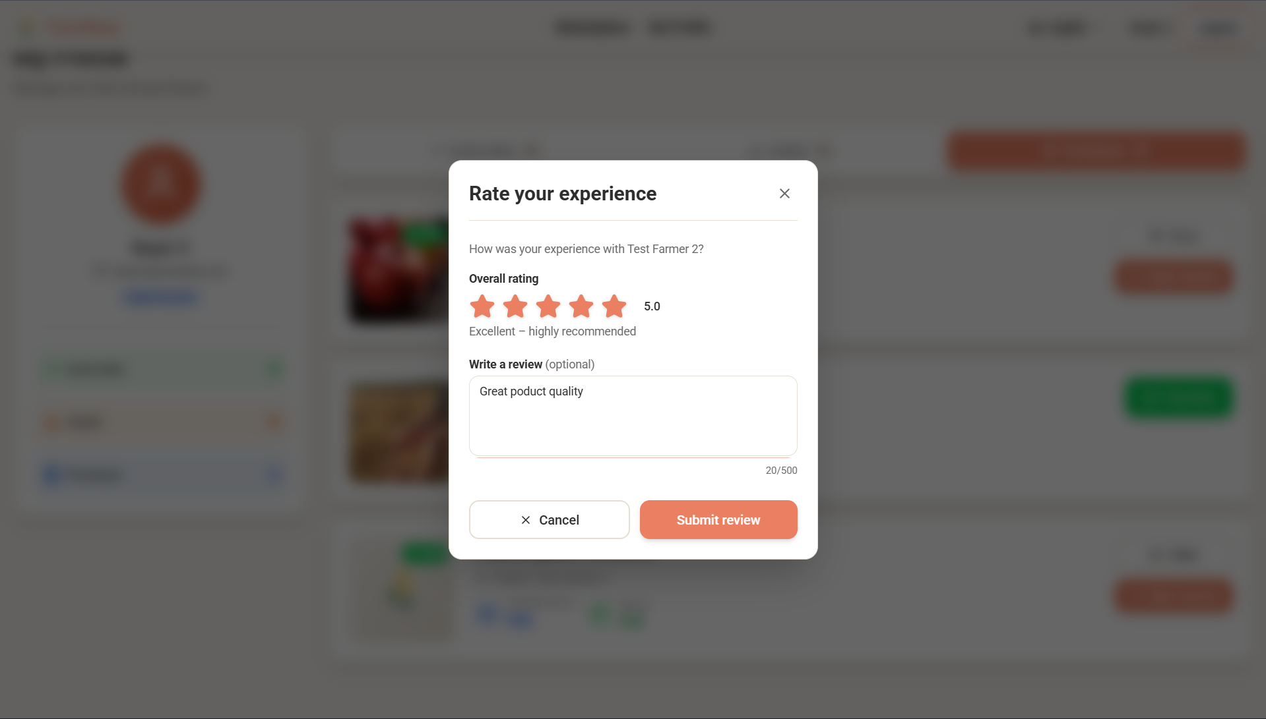

- Farmer Profile Page with reviews (For Buyers):
